Step 1: Visit this website.
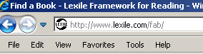

Step 2: Enter your Lexile score, as well as your range. Your range should be 100L below and 50L above your current score.
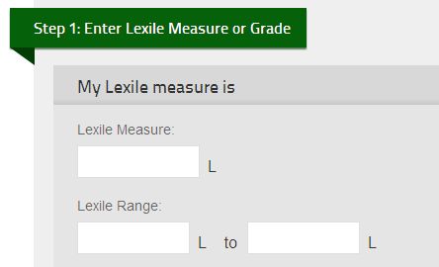

Step 3: Choose 2-3 categories of interest.
100L below

50 L above
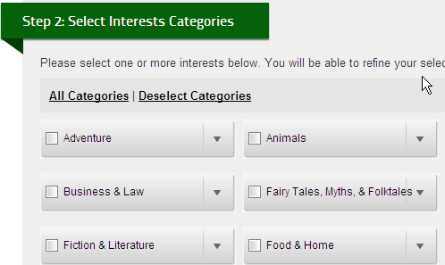

Step 4: Narrow your search results with the menu on the right hand side. The appropriate age range for fourth graders is 8 – 11 years old.
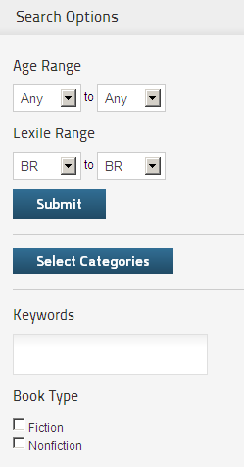
Step 5: Browse the selections. Add 4-5 books to your reading list. Revise your search if “0” matches comes up!
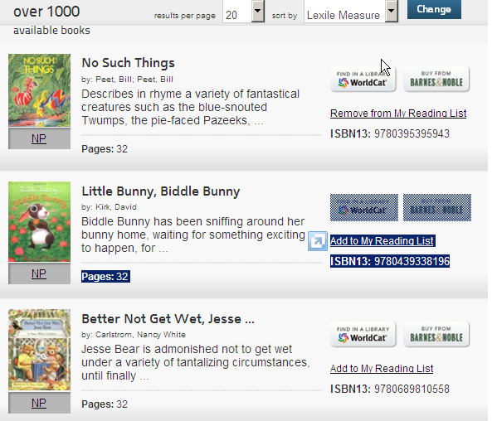
Step 6: Use the “Quick Search” tool to find the lexile of your current just right books.
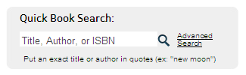

Step 7: Evaluate how appropriate your texts are using the Quick Book Search and lexile score in comparison to your Lexile range!

